**PROJECT-13**

**Blending of two images - Image Enhancement**

EE5356 Digital Image Processing

Dr. K. R. Rao

Submitted By:

Ashutosh Desai

UTA ID:1001388602

Email: - ashutoshrajesh.desai@mavs.uta.edu

SPRING-2018

**Problem Statement:**

Write a MATLAB program that will read two images and **blend the two images** in a user defined manner. Plot the results fordifferent **α** values and compare the output.

**Hints:**

1. Read “Cameraman and Lena” Test Images from course

Webpage: <http://www.uta.edu/faculty/krrao/dip/Courses/EE5356/index.htm>

1. Use the below formula for C:

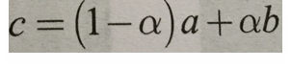

c) **a, b, c** and **α** are used defined variables

**a** = Read Cameraman image

**b =** Read Lena image

**c** = Blend two images and store it on c

**α** = Value of α can be in between 0 to 1 and provided on rum time

**MATLAB CODE:**clc;

clear all;

close all;

Input_Img=imread('D:\STUDY\DIP\Test img\lena512.bmp');

Img=imresize(imread('D:\STUDY\DIP\Test img\cameraman.bmp'),[512,512]);%converting image size to 512*512

%prompting for input alpha value at runtime.

prompt = 'What is the alpha value? ';

alpha = input(prompt)

%we need to enter alpha values between [0,1]

if(alpha<0||alpha>1)

warning('you can not enter alpha value outside [0,1]')

else

c=((1-alpha)*Input_Img)+(alpha*Img); %used the given expression to blend 2 images

titl=sprintf('Blended Images for alpha=%0.1f',alpha);

imshow(c);title(titl);

end

**OUTPUT:**

We entered the alpha values 0,0.1,0.2,0.3,0.4,0.5,0.6,0.7,0.8,0.9,1 at runtime and generated the below images

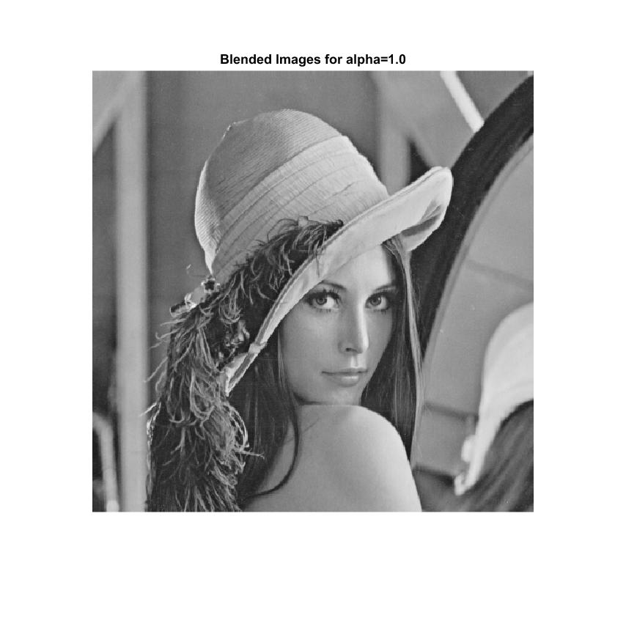

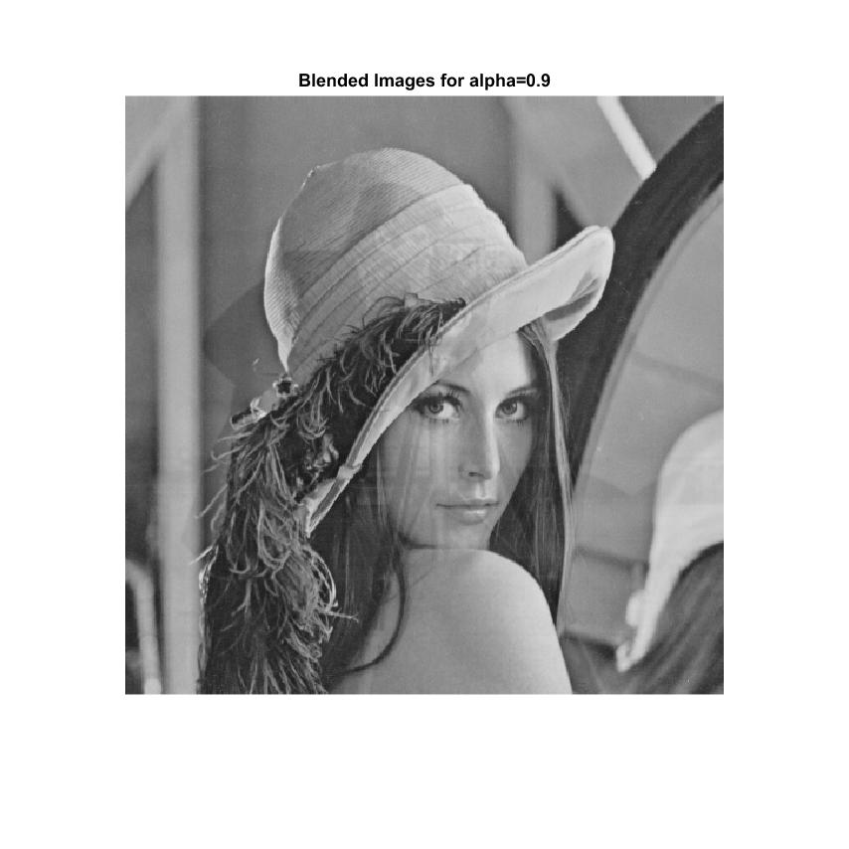

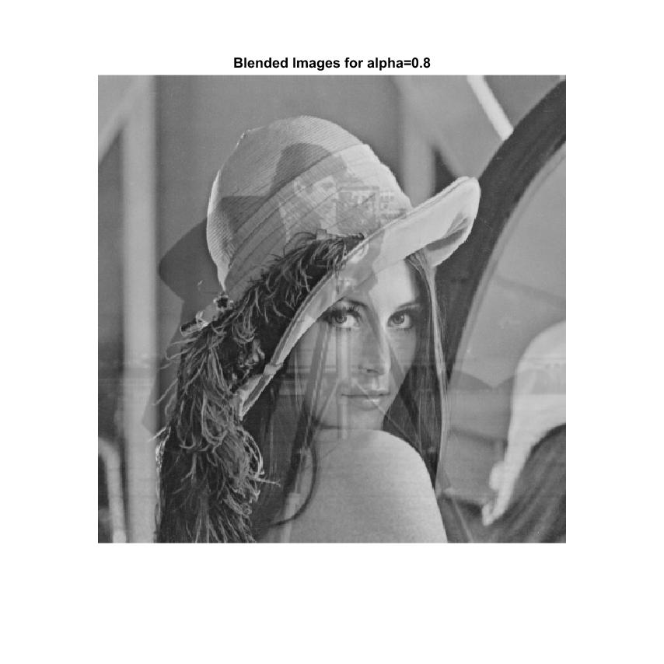

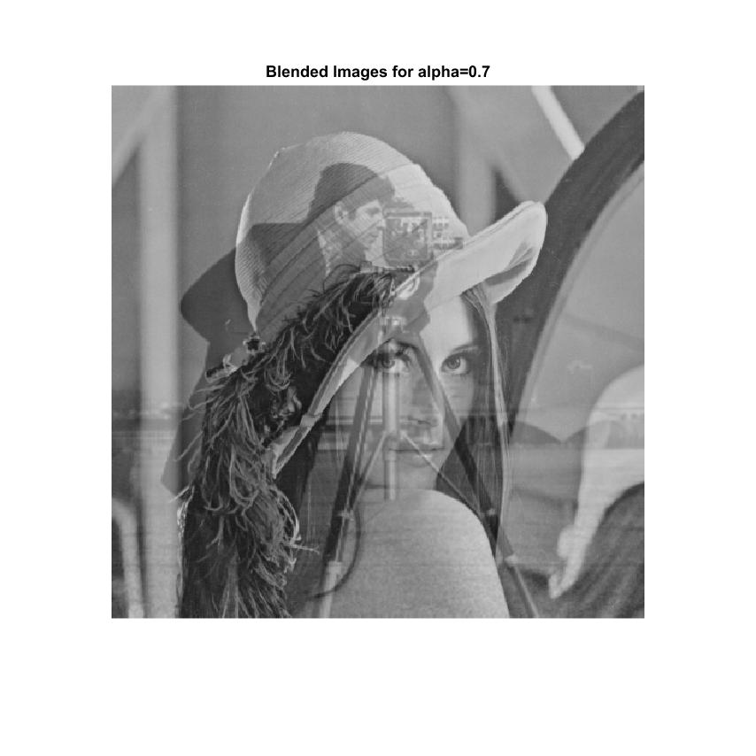

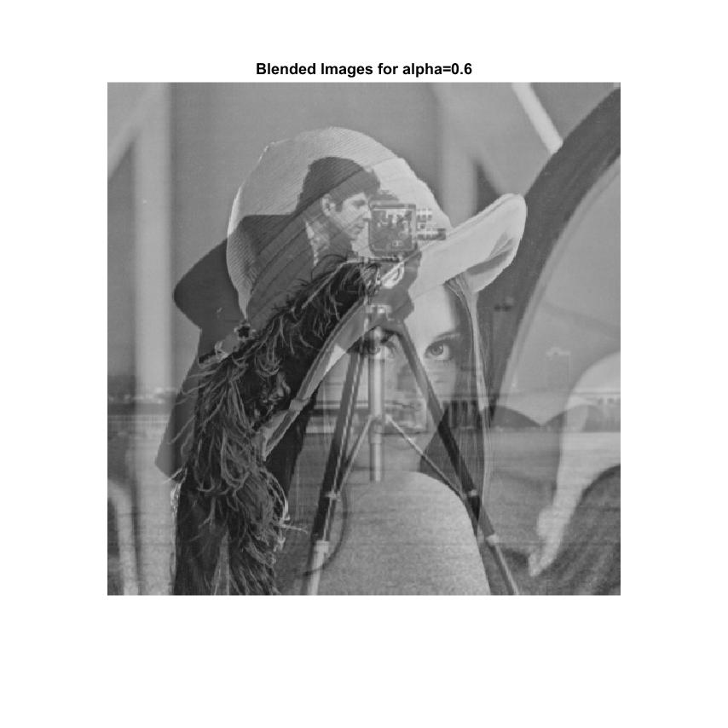

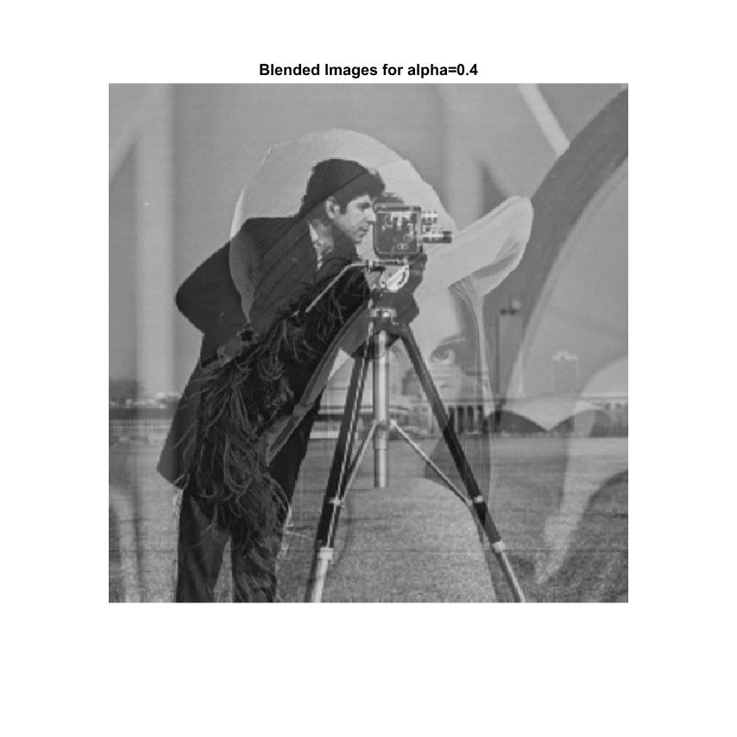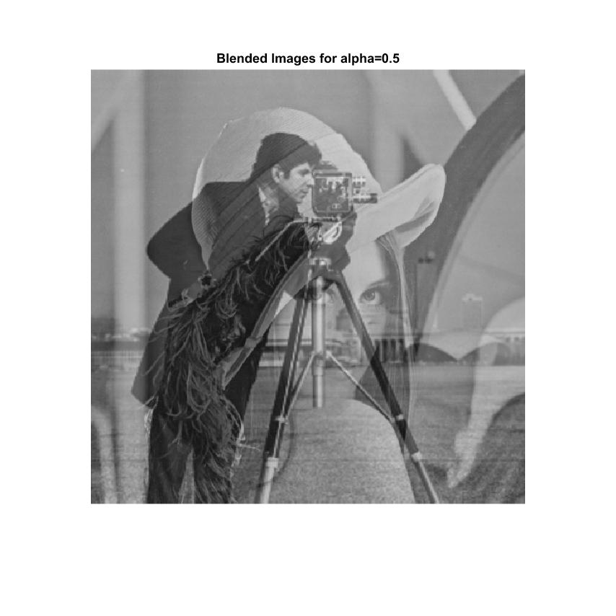

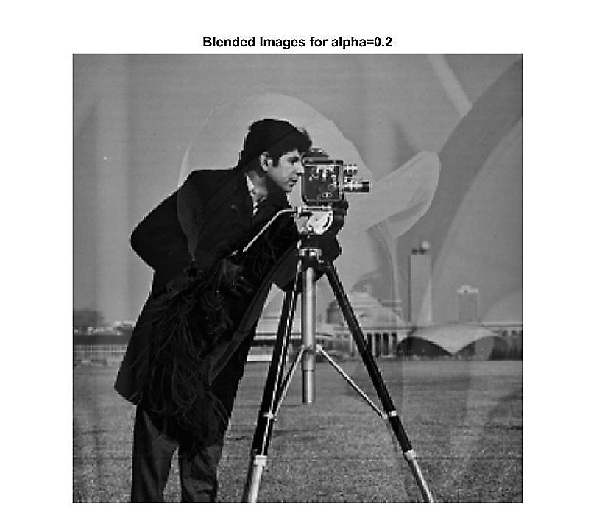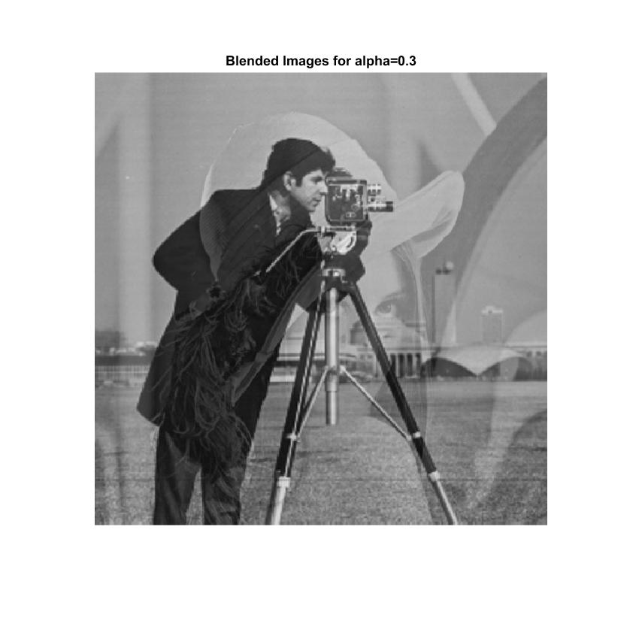

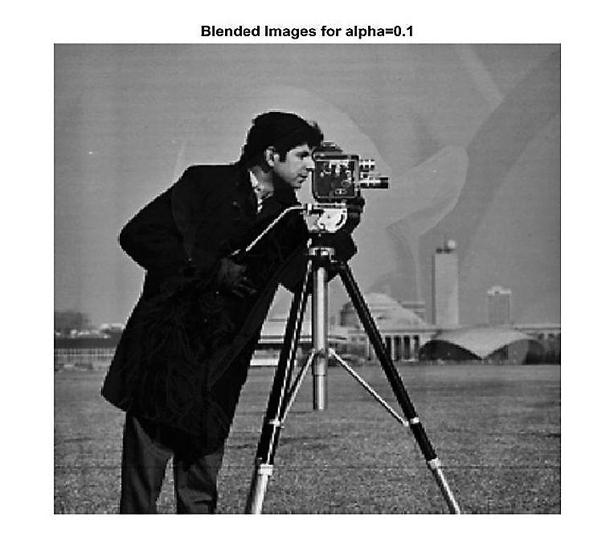

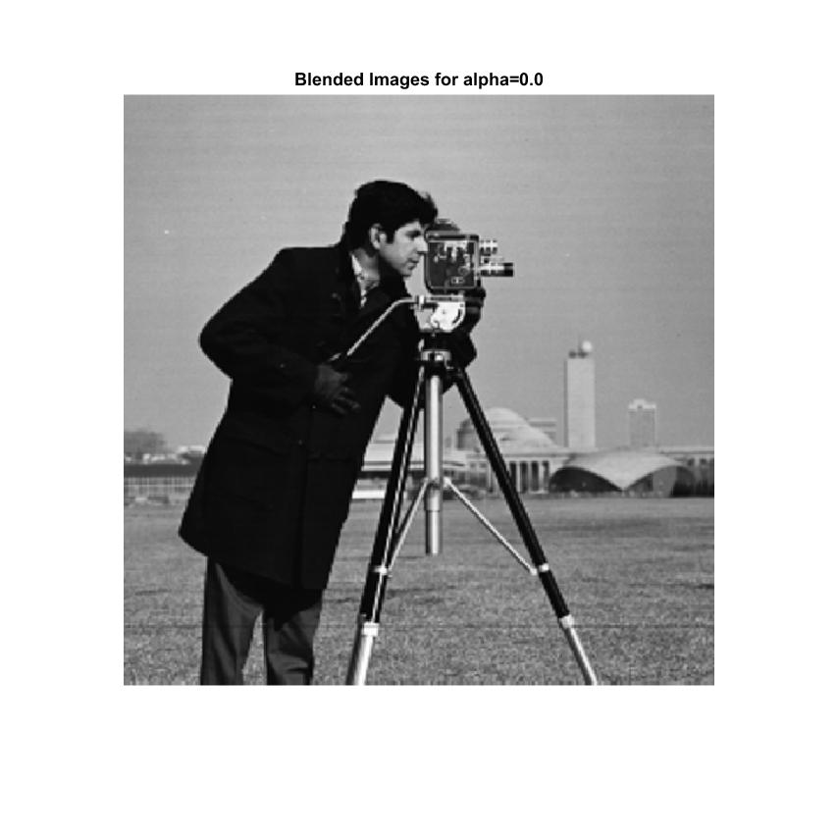

**PROCEDURE:**

* First we read the image lena512.bmp (512x512) into variable ‘b’ and then we read the cameraman.bmp (256x256) image into the variable ‘a’ and resized the image to 512x512 using ***imresize*** command.
* ***imresize*** command returns image B that has the number of rows and columns specified by outputSize, a two-element vector of the form [numrows numcols].
* Then we prompted the alpha values to enter between 0 and 1.
* Then we used the given expression c=(1- **α**) a+ αb to comp  
  ute the blended image c if the condition(**α** ∈ [0, 1]) satisfies.

**OBSERVATION and CONCLUSION:**

We can observe that the blending of the images depends on the alpha value as alpha value increases upto 1, the image ‘b’ dominates image ‘a’ and when the alpha becomes 0, the image ‘a’ dominates image ‘b’. So the composition of both images changes as the the alpha varies from the given expression c=(1- **α**) a+ αb. So here blending of two images is nothing but superimposing two images with relative composition.